06th October 2026

LETTER OF RECOMMENDATION

I am writing to you with regards to Ms. Supraja U who has requested that I write a letter of recommendation on her behalf. I support her decision and strong desire to take her dedication and skill to the next level.

Supraja has worked for the duration of May 2026 to August 2026 as an Intern in our organization. Over the time that I have known Supraja, she has consistently performed her duties with competence and often goes the extra time, doing more than expected.

Supraja is an excellent problem solver. In addition, She is an excellent communicator and has the skills and personally needed to be a leader. She has been exposed to different processes and found to be Punctual, Hard Working and Inquisitive.

Your program will benefit by training and learning his technical skills to become a world-class professional. and I hope that her recommendation will have your favorable consideration.

For Gradtwin Services (OPC) Private Limited
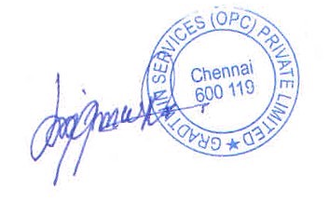

Kanishrajiah Durairaju

Manager - Human Resource

